B-number: B00928112
Jigeesha Sanjeev Jain

Homework 1 Solutions

- [75%] Design an ER diagram for the Student Registration System based on the provided Requirements Document. Remember to indicate the key for each entity set and the connectivity of each relationship; 2% will be deducted every time a key is not underlined. Use (min, max) format to indicate connectivity. (Note: Many constraints cannot be represented in the ER diagram and they will be represented at later stages of the design. Question 3 of this homework asks you to list these constraints.)

Answer: Refer the ER diagram below.

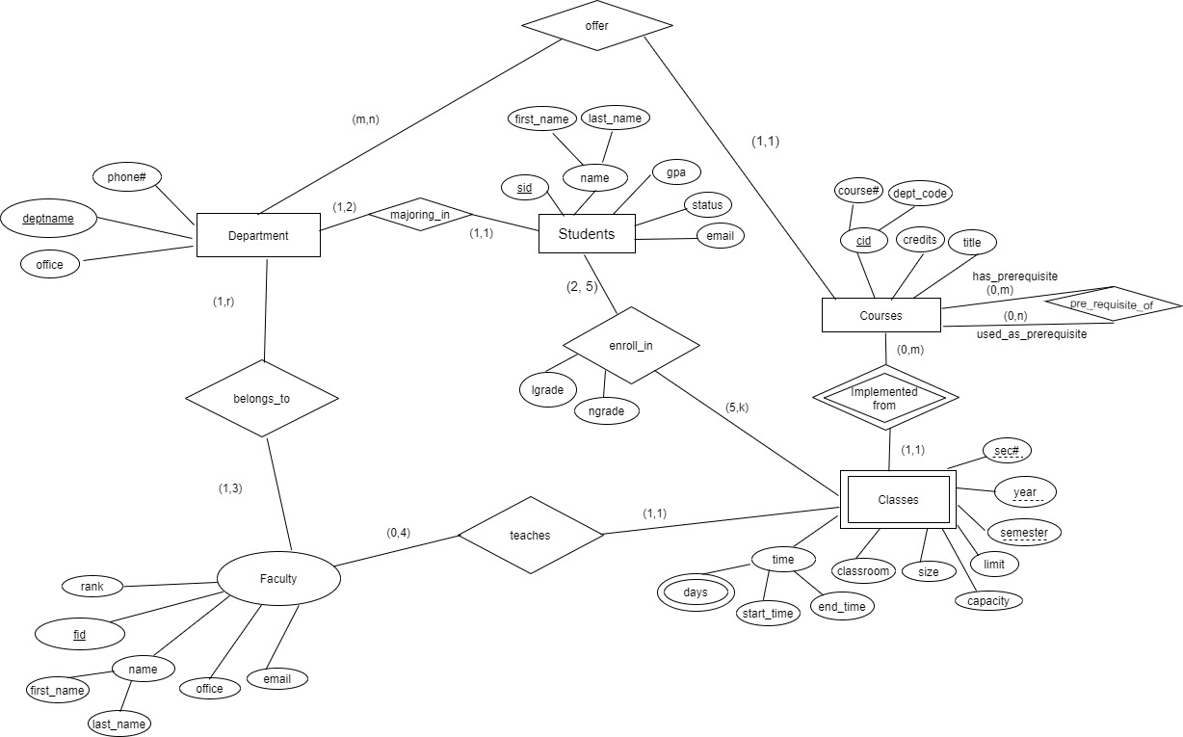

- [10%] Discuss whether it is a good idea to create a super entity set for Students and Faculty in the ER diagram for the Student Registration System or not.

Answer: To begin with, there is no such advantage to create a super entity set for Students and Faculty. Generally, a super entity set is created when multiple entity sets share significant common attributes. This is hardly the case for Students and Faculty from the requirements given in student registration system. There are only two common attributes i.e., name and email between Students and Faculty, rest of them are unique attributes. Most importantly, even though they both have relationships with Classes and Departments, they have totally different relationships. In other words, their behaviors are completely different. Moreover, there is no such redundancy caused by keeping Students and Faculty separate. Hence, it is not a good idea to create a super entity set of Students and Faculty in ER diagram for the Student Registration system.

- [15%] Identify and discuss constraints in the Requirements Document for the Student Registration System that cannot be expressed using the ER model discussed in class. First list the constraints not represented in the ER diagram for each entity set separately. Then list the constraints involving multiple entity sets.

Answer: Constraints that cannot be represented in the ER diagram are as follows:

- Students:
- Specific values of status (freshman, sophomore, junior, Senior, Graduate).
- Specific values of GPA (decimal 0 to 4).
- Different students have different email addresses.

- Courses:
- Specific values of course# (100-499 for undergraduate and 500—799 for graduate courses).
- Specific values of credit hours(3 hours for graduate courses and 4 hours for undergraduate courses).

- Classes:
- Specific values for days (Monday, Tuesday, Wednesday, Thursday, Friday).
- Specific values for semester (Spring, Fall, Summer 1, Summer 2).
- Classes are uniquely identified by the combination of the following attributes: cid, sect#, year, and semester.
- The actual size of a class must not exceed the limit of the class.
- The limit of a class must not exceed the capacity of the assigned classroom.
- No classes of overlapping times can be assigned to the same classroom.

- Departments:
- Different departments have different offices.

- Faculty:
- Valid values for faculty rank are {lecturer, assistant professor, associate professor, professor}.
- Different faculty members have different offices and email addresses.

Additional constraints include:

- The values of lgrade are limited to {A, B, C, D, F, I, null}.
- The values for ngrade are limited to {4,3,2,1,0, null}.
- The values of lgrade and ngrade for each enrollment must satisfy the following correspondences: A ←→ 4, B ←→ 3, C ←→ 2, D ←→ 1, F ←→ 0 and I ←→ null.
- Courses and their prerequisite courses do not form cycles.
- No faculty member can teach classes with overlapping times.
- The student has completed all the prerequisite courses with a grade of at least C.
- The time of the class does not overlap with the times of the classes the student has already enrolled in.

In short, several types of constraints cannot be expressed in the ER diagram as discussed in the class. The reasons can be found as follows:

- Attribute values: The constraints on the valid values that an attribute can take cannot be expressed as the ER model does not consider individual values.
- Additional keys: Since only one key can be denoted for each entity set, additional keys cannot be expressed.
- Values of relationships/constraints across different attributes.
- Some complex relationships / constraints include: (a) courses and their pre requisite courses do not form cycles; (b) no faculty member can teach classes with overlapping times; (c) no classes with overlapping times assigned to the same classroom; (d) a student cannot be registered in the same class for more than once; (e) a student cannot be register in classes with overlapping times; (f) a student has completed all the prerequisite courses with a grade of at least C

Many constraints that cannot be represented in the ER diagram and they will be implemented at later stages of the design during the application development.

